ENTITY RELATIONSHIP DIAGRAM – MUSIC STREAMING MANAGEMENT SYSTEM

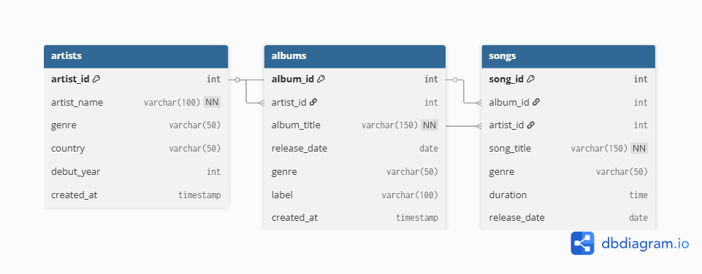

Figure 1: Entity Relationship Diagram (ERD) for the Music Streaming Database

The Entity Relationship Diagram (ERD) above represents the database structure of the **Music Streaming System**. The database consists of three main tables — **Artists**, **Albums**, and **Songs** — which are related through primary and foreign key relationships.

The **Artists** table stores key details about music creators such as *artist_id, artist_name, genre, country*, and *debut_year*. The **Albums** table includes information such as *album_id, artist_id, album_title, release_date, genre,* and *label*, linking each album to its respective artist. The **Songs** table records details for individual tracks including *song_id, artist_id, album_id, song_title, genre, duration*, and *release_date.*

Together, these tables illustrate a one-to-many relationship where one artist can produce multiple albums, and each album can contain several songs. This structure ensures organized data storage, easy retrieval, and scalability for future system expansion.